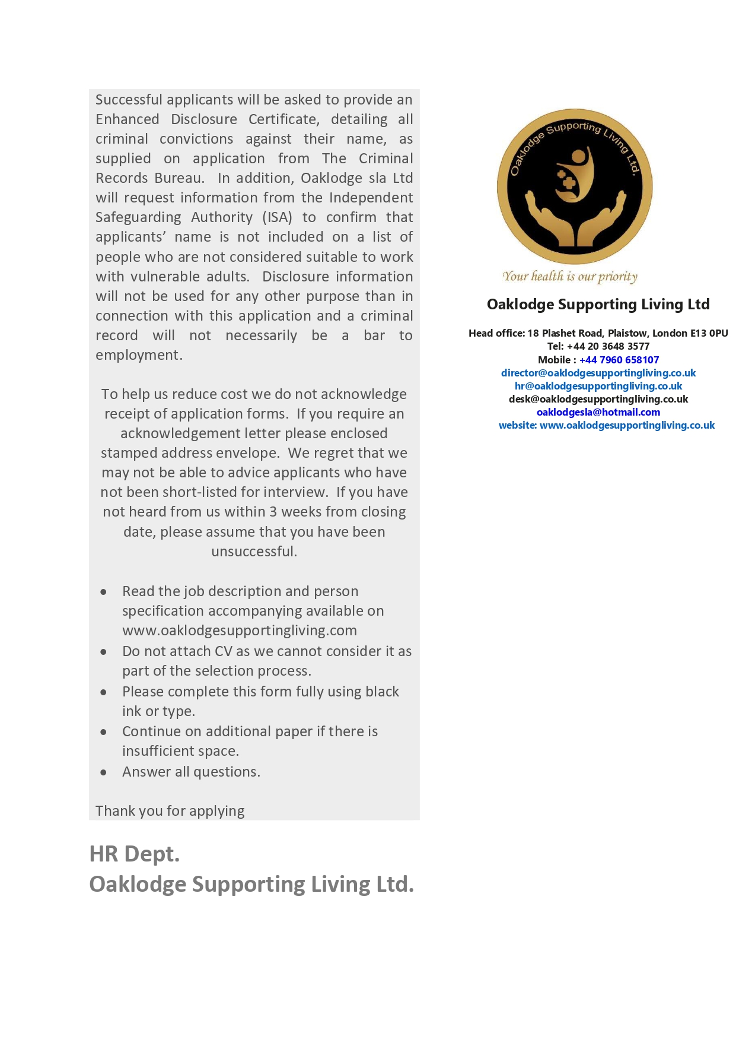

**JOB APPLIED FOR**

|  |  |  |  |
| --- | --- | --- | --- |
| **Post Reference Number:** |  | **Posted at: :** |  |

|  |  |  |
| --- | --- | --- |
| **Job Title:** |  |  |

**PERSONAL INFORMATION**

|  |  |  |  |
| --- | --- | --- | --- |
| **Title:** | **(Mr****/Ms****/Mrs****/Miss****)** | **Date of Birth:** |  |

|  |  |  |  |
| --- | --- | --- | --- |
| **Surname:** |  | **Forename:** |  |

|  |  |  |  |
| --- | --- | --- | --- |
| **Address:** |  | | |
|  |  | | |
|  | | |
|  | |  |  |
|  | | **Postcode:** |  |

|  |  |  |  |  |
| --- | --- | --- | --- | --- |
| **Do you need a work permit?** | **Yes** |  | **No** |  |

|  |  |
| --- | --- |
| **N.I Number:** |  |

|  |  |  |  |
| --- | --- | --- | --- |
| **NHS number:** |  |  |  |

|  |  |  |  |
| --- | --- | --- | --- |
| **Mobile Tel No:** |  |  |  |

|  |  |
| --- | --- |
| **E-Mail Address** |  |

**YOUR AVAILABILITY**

|  |  |  |  |  |  |  |  |  |  |  |  |  |  |  |
| --- | --- | --- | --- | --- | --- | --- | --- | --- | --- | --- | --- | --- | --- | --- |
| Days |  | Monday |  | Tuesday |  | Wednesday |  | Thursday |  | Friday |  | Saturday |  | Sunday |
|  |  |  |  |  |  |  |  |  |  |  |  |  |  |  |
| Time |  |  |  |  |  |  |  |  |  |  |  |  |  |  |

**EMPLOYMENT HISTORY**

**Please list in order (most recent job first) the organisations you have worked for, full-time and part-time, paid and unpaid, including relevant voluntary work and include any periods of non-employment.**

|  |  |  |  |  |  |  |
| --- | --- | --- | --- | --- | --- | --- |
| **From** |  | **To** |  | **Employer** |  | **Job Title/Main Duties** |
|  | | | | | | |
|  |  |  |  |  |  |  |
|  | | | | | | |
|  |  |  |  |  |  |  |
|  | | | | | | |
|  |  |  |  |  |  |  |
|  | | | | | | |
|  |  |  |  |  |  |  |
|  | | | | | | |
|  |  |  |  |  |  |  |
|  | | | | | | |
|  |  |  |  |  |  |  |
|  | | | | | | |
|  |  |  |  |  |  |  |
|  | | | | | | |
|  |  |  |  |  |  |  |
|  | | | | | | |
|  |  |  |  |  |  |  |
|  |  |  |  |  |  |  |
|  |  |  |  |  |  |  |
|  |  |  |  |  |  |  |
|  |  |  |  |  |  |  |
|  |  |  |  |  |  |  |

**EDUCATION**

**Please include details of studies undertaken and qualifications achieved from secondary education onwards:**

|  |  |  |  |  |  |  |
| --- | --- | --- | --- | --- | --- | --- |
| **Dates attended** |  | **School, College or University** |  | **Course Title** |  | **Qualifications and grades obtained** |
|  |  |  |  |  |  |  |
|  |  |  |  |  |  |  |
|  |  |  |  |  |  |  |
|  |  |  |  |  |  |  |
|  |  |  |  |  |  |  |
|  |  |  |  |  |  |  |
|  |  |  |  |  |  |  |
|  |  |  |  |  |  |  |
|  |  |  |  |  |  |  |

**Do you hold current certificates in?**

|  |  |  |  |  |  |  |  |  |  |  |
| --- | --- | --- | --- | --- | --- | --- | --- | --- | --- | --- |
| **Challenging Behaviour** | **Yes** |  | **No** |  |  | **Safe Administration of Medicines** | **Yes** |  | **No** |  |
|  |  |  |  |  |  |  |  |  |  |  |
| **Deprivation of Liberty Safeguards** | **Yes** |  | **No** |  |  | **Safeguarding Vulnerable Adults** | **Yes** |  | **No** |  |
|  |  |  |  |  |  |  |  |  |  |  |
| **Diversity and Equality** | **Yes** |  | **No** |  |  | **QCF (NVQ) Level 2** | **Yes** |  | **No** |  |
|  |  |  |  |  |  |  |  |  |  |  |
| **First Aid Awareness** | **Yes** |  | **No** |  |  | **QCF (NVQ) Level 3** | **Yes** |  | **No** |  |
|  |  |  |  |  |  |  |  |  |  |  |
| **Food Hygiene** | **Yes** |  | **No** |  |  | **QCF (NVQ) Level 4** | **Yes** |  | **No** |  |
|  |  |  |  |  |  |  |  |  |  |  |
| **Health and Safety** | **Yes** |  | **No** |  |  | **QCF (NVQ) Level 5** | **Yes** |  | **No** |  |
|  |  |  |  |  |  |  |  |  |  |  |
| **Infection Control** | **Yes** |  | **No** |  |  | **QCF (NVQ) Level 6** | **Yes** |  | **No** |  |
|  |  |  |  |  |  |  |  |  |  |  |
| **Mental Capacity** | **Yes** |  | **No** |  |  | **QCF (NVQ) Level 7** | **Yes** |  | **No** |  |
|  |  |  |  |  |  |  |  |  |  |  |
| **Nutrition and Diet** | **Yes** |  | **No** |  |  | **QCF (NVQ) Level 8** | **Yes** |  | **No** |  |
|  |  |  |  |  |  |  |  |  |  |  |
| **Person Centred Care** | **Yes** |  | **No** |  |  | **Others *(please specify):*** |  | | | |

**Please include details of any other training including NVQs, short courses, company training:**

|  |  |  |  |  |  |  |
| --- | --- | --- | --- | --- | --- | --- |
| **Dates attended** |  | **College or Firm** |  | **Title of Training Programme or Course** |  | **Qualifications and grades obtained** |
|  |  |  |  |  |  |  |
|  |  |  |  |  |  |  |
|  |  |  |  |  |  |  |
|  |  |  |  |  |  |  |
|  |  |  |  |  |  |  |
|  |  |  |  |  |  |  |
|  |  |  |  |  |  |  |
|  |  |  |  |  |  |  |
|  |  |  |  |  |  |  |
|  |  |  |  |  |  |  |
|  |  |  |  |  |  |  |
|  |  |  |  |  |  |  |
|  |  |  |  |  |  |  |
|  |  |  |  |  |  |  |
|  |  |  |  |  |  |  |
|  |  |  |  |  |  |  |

**RELEVENT EXPERIENCE AND SKILLS ETC,**

**The information you provide in this section is important in assessing your application. Please use the space to explain your reasons for applying for the post, showing how your skills, experience and personal qualities relate to the job requirements as set out in the job description and person specification. These may have been gained through previous employment, voluntary/community work, spare time activities or training. Please include details of membership of relevant professional associations, and anything else which you think is appropriate to this application.**

|  |
| --- |
|  |

|  |  |  |  |  |  |
| --- | --- | --- | --- | --- | --- |
| **Do you have any relatives/friends currently employed by Oaklodge Supporting** |  | **Yes** |  | **No** |  |

**If YES please provide details.**

|  |
| --- |
|  |

**CONVICTIONS**

**Please state any convictions you have had for criminal offences including those that may be “spent” under the Rehabilitation of Offences Act 1974. “Spent” convictions must be declared due to the client group which you may have contact while working for Oaklodge Supporting Living Ltd**

**Any information will be kept confidential and will be considered only in relation to the job you are applying for.**

|  |  |  |  |  |  |
| --- | --- | --- | --- | --- | --- |
| **Have you ever been convicted of any criminal offence by a Court of Law** |  | **Yes** |  | **No** |  |

**If YES please give details of all convictions.**

|  |
| --- |
|  |

**REFERENCES**

**We ask for the name of two references. One of them must be your most recent employer. If you have not worked for some time or have never worked, please give the name of someone, (not a relative of friend), who can comment on your ability to do the job for which you are applying.**

|  |  |  |  |  |  |  |
| --- | --- | --- | --- | --- | --- | --- |
|  | **Employment Reference** | |  |  | **Character Reference** | |
|  |  | |  |  |  | |
| **Name:** |  | |  | **Name:** |  | |
|  |  | |  |  |  | |
| **Position:** |  | |  | **Position:** |  | |
|  |  | |  |  |  | |
| **Work**  **Relationship** |  | |  | **Work**  **Relationship** |  | |
|  |  | |  |  |  | |
| **Organisation:** |  | |  | **Organisation:** |  | |
|  |  | |  |  |  | |
| **Address:** |  | |  | **Address:** |  | |
|  |  |  |  |
| **Postcode:** |  | **Postcode:** |  |
|  |  | |  |  |  | |
| **Telephone Number:** |  | |  | **Telephone Number:** |  | |
|  |  | |  |  |  | |
| **Email Address:** |  | |  | **Email Address:** |  | |

**DECLARATION**

**Regulation 19, Health and Social Care Act 2008 (Regulated Activities) Regulations 2014 requires that all employees who work in care homes are both physically and mentally fit to undertake their duties.**

**Please answer the following questions:**

|  |  |  |  |  |
| --- | --- | --- | --- | --- |
| **How many days were you absent from work due to sickness in the last year?** | **Yes** |  | **No** |  |
|  |  |  |  |  |
| **Have you ever suffered from?**  **Allergies, eczema, dermatitis or other skin troubles?** | **Yes** |  | **No** |  |
|  |  |  |  |  |
| **Do you suffer from:**  **Epilepsy, migraine, asthma, angina, heart trouble or any condition requiring long-term medical help or an ongoing programme of medication** | **Yes** |  | **No** |  |
|  | | | |
|  |  |  |  |  |
| **Have you ever suffered from?**  **Mental illness including anxiety, stress, depression or nervous debility?** | **Yes** |  | **No** |  |
|  |  |  |  |
|  |  |  |  |  |
| **Have you ever required treatment for?**  **Hernia or rupture, rheumatism, back problems, slipped disc, sciatica or Repetitive Strain Injury (RSI)?** | **Yes** |  | **No** |  |
|  |  |  |  |
|  |  |  |  |  |
| **Have you been tested for Covid 19?**  **And can you provide proof from NHS.** | **Yes** |  | **No** |  |
|  |  |  |  |

**If you have answered YES to any of the health questions on the previous page, please provide further details below.**

|  |
| --- |
|  |

**Declaration:**

**I confirm that I know of no reason, in relation to my physical and /or mental health why I would not be able to undertake the duties required for the post applied for.**

|  |  |  |  |  |
| --- | --- | --- | --- | --- |
| **Signature:** |  |  | **Date:** |  |

**TELL US MORE**

**Please use this space to tell us more about yourself and to add information that you feel is important in your application. Tell us more about any additional skills you have, hobbies, interests and achievements.**

**Please continue on a separate sheet if you wish.**

|  |
| --- |
|  |

**DECLARATION**

**Please complete the following declaration and sign it in the appropriate space below. If this declaration is not completed and signed, your application will not be considered.**

**I CONFIRM THAT TO THE BEST OF MY KNOWLEDGE AND BELIEF THE INFORMATION I HAVE GIVEN IS CORRECT AND UNDERSTAND THAT ANY CONTRACT OFFERED TO ME IS BASED ON THE INFORMATION PROVIDED. I ALSO UNDERSTAND THAT IF I AM APPOINTED AND INFORMATION IS SUBSEQUENTLY FOUND TO BE FALSE, I MIGHT BE DISMISSED.**

|  |  |  |  |  |
| --- | --- | --- | --- | --- |
| **Signature:** |  |  | **Date:** |  |

**Important**

**Please make sure that you have signed and dated the Medical Health Questionnaire Form**

**Data Protection Information**

|  |
| --- |
| **The information which you have supplied on this form will be processed and may be held on computer, and will be held on your personal records file if you are appointed. The information will also be used for equality monitoring and statistical purposes. By signing this application, you will be deemed to have given your consent to this, including information which may be considered to be sensitive and personal** |

**EQUAL OPPORTUNITY MONITORING**

**Ethnic origin**

**Choose one section from a) to e) then tick the appropriate box to indicate your cultural background.**

|  |  |  |  |  |  |  |  |  |  |  |  |  |  |  |
| --- | --- | --- | --- | --- | --- | --- | --- | --- | --- | --- | --- | --- | --- | --- |
| **a) White** | | | | | | | | **d) Asian or Asian British** | | | | | | |
|  | **British** | | | | | | |  | **Indian** | | | | | |
|  |  | | | | | | |  |  | | | | | |
|  | **Irish** | | | | | | |  | **Pakistan** | | | | | |
|  |  | | | | | | |  |  | | | | | |
|  | **Any other white background**  ***Please specify*** | | | | | | |  | **Any other Asian background**  ***Please specify*** | | | | | |
|  |  | | | | | | |  |  | | | | | |
|  |  | | | | | |  |  |  | | | | |  |
|  |  | | | | | | |  |  | | | | | |
| **b) Mixed** | | | | | | | | **e) Black or Black British** | | | | | | |
|  |  | | | | | | |  |  | | | | | |
|  | **White and Black Caribbean** | | | | | | |  | **Caribbean** | | | | | |
|  |  | | | | | | |  |  | | | | | |
|  | **White and Black African** | | | | | | |  | **African** | | | | | |
|  |  | | | | | | |  |  | | | | | |
|  | **White and Asian** | | | | | | |  | **Any other Black background**  ***Please specify*** | | | | | |
|  |  | | | | | | |  |  | | | | | |
|  | **Any other mixed background**  ***Please specify*** | | | | | | |  |  | | | | |  |
|  |  | | | | | | |  |  | | | | | |
|  |  | | | | | |  |  |  | | | | | |
|  |  | | | | | | |  |  | | | | | |
| **c) Chinese or other Ethnic group** | | | | | | | |  | **Disability** | | | | | |
|  | **Chinese** | | | | | | |  | **The disability Discrimination Act 1995 Defines a person as having a disability if he/she has a Physical or Mental impairment which has a substantial and long-term adverse effect on his/her ability to carry out normal day-to-day activities.** | | | | | |
|  |  | | | | | | |  |
|  | **Vietnamese** | | | | | | |  |
|  |  | | | | | | |  |
|  | **Any other (*Please specify*)** | | | | | | |  |
|  |  | | | | | | |  |
|  |  | | | | | | |  | **Do you have a disability as defined above?** | | | | | |
|  |  | | | | | | |  |  | | | | | |
| **Gender** | | | | | | | |  | **Yes** |  |  | **No** |  | |
|  |  | | | | | | |  |  | | | | | |
|  |  | **Male** | |  | **Female** | | |  | **If the above does not apply to you, but you do consider yourself to have a disability then please give more details** | | | | | |
|  |  | | | | | | |  |
|  | Age | |  | | |  | |  |